**Use Address window with code logic in smart forms**

For the initial steps to create a smart form, please refer the previous demos.

1. Create a smart form.

2) Double click on Form Interface and declare the following parameter

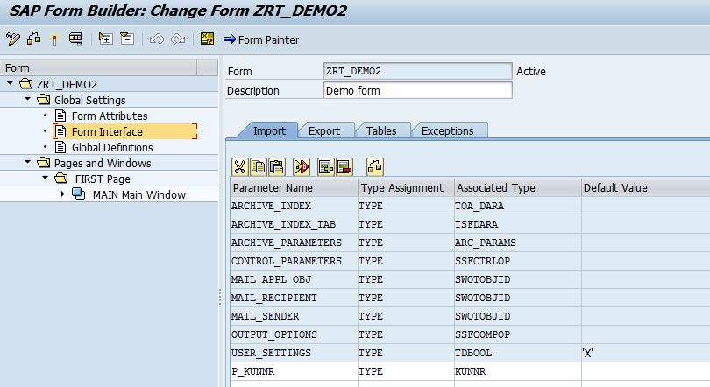

3) Double click on global definitions and add the variable LV_ADRNR

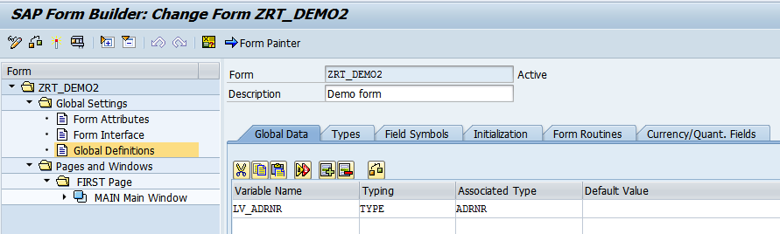

4) Right click on MainWindow.Create-FlowLogic->Program Lines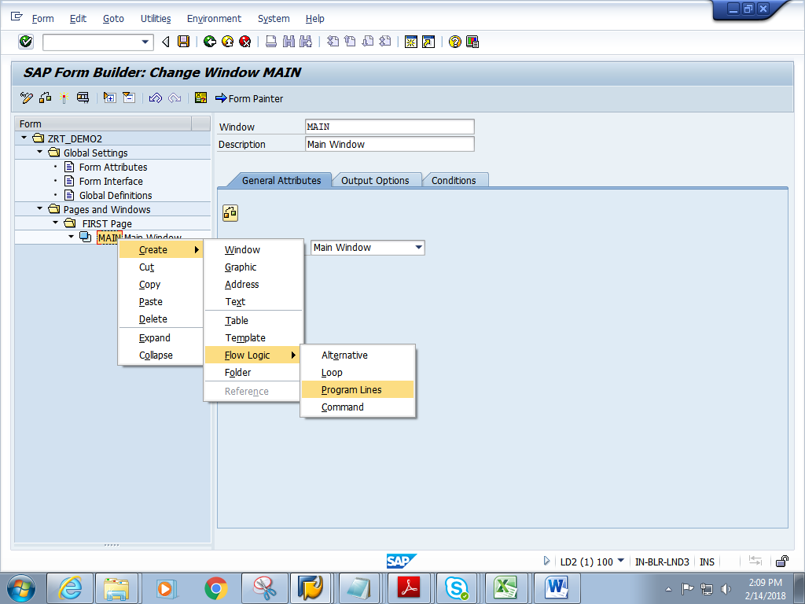

5) Double click on CODE1 and add the below code. Add the Input and Output parameters

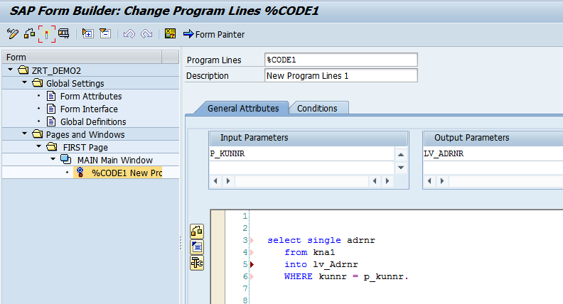

select single adrnr from   kna1  into lv_adrnr where kunnr = lv_kunnr.

6) Right click on Code1. Create-> Address..

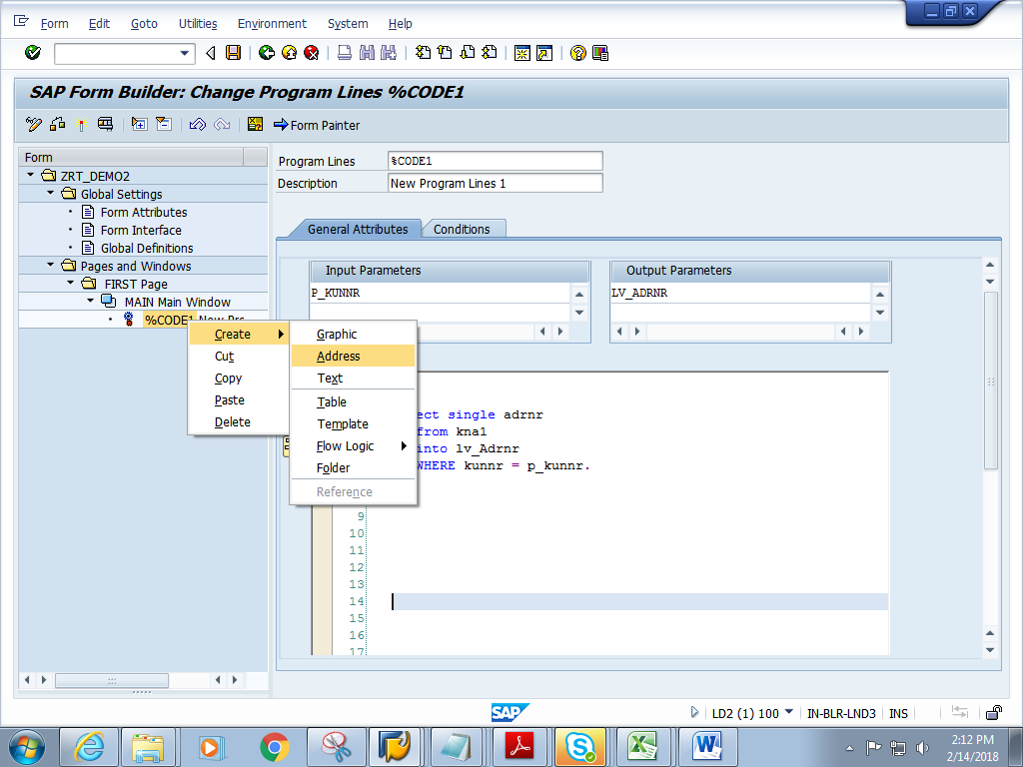

7) Double click on Address .Give Address number as shown below

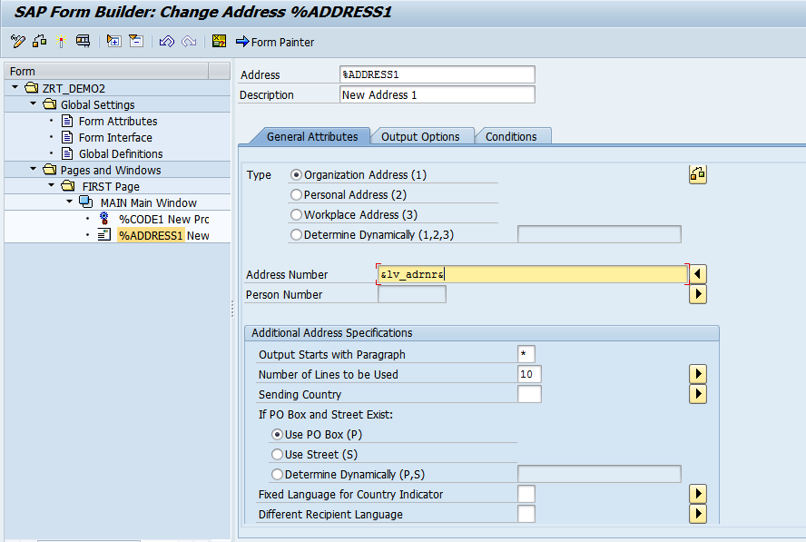

8) Save and activate the form.

9) Execute the form .Execute the function module. **Give the KUNNR (any KUNNR no from KNa1 table)**

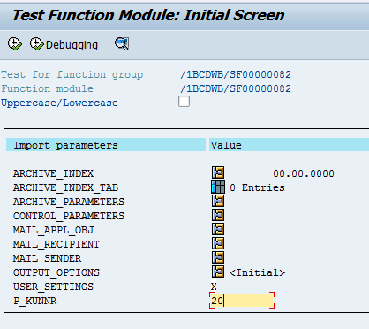

10) Click on Print preview

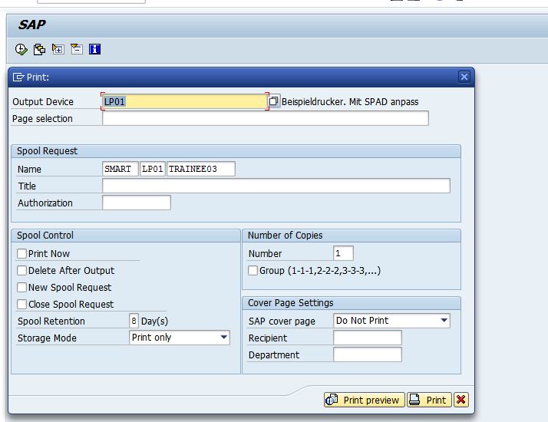

11) Expected output is as follows.

